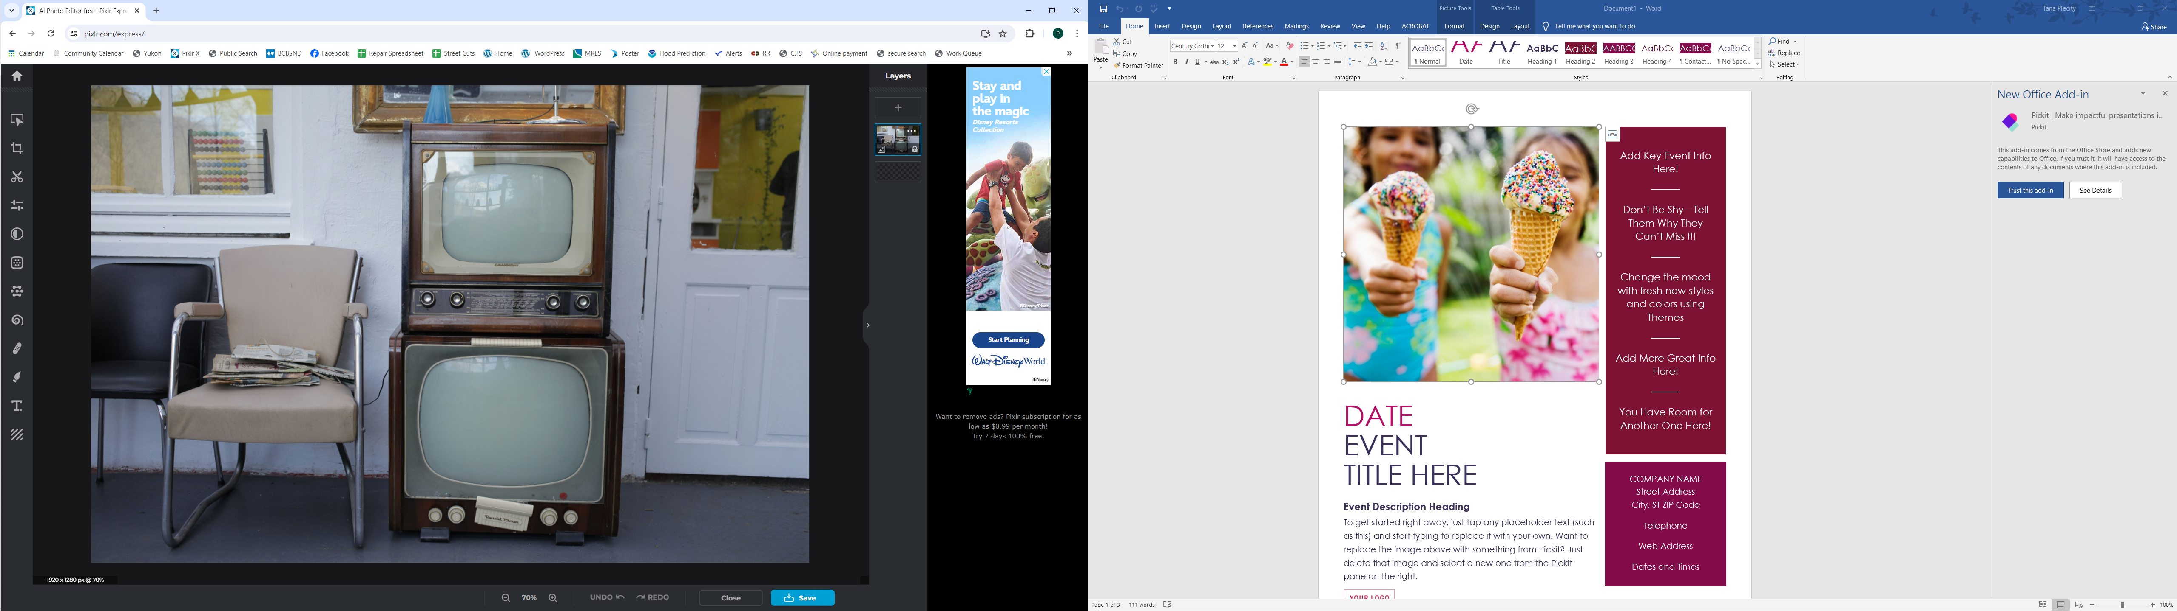  May 13th-17th  Electronics Clean up  Bring your unwanted TVs, computers, and printers to the Transfer Station during the week of May 13th -17th for $0.75 per pound  (CASH ONLY)  WHO: All Residents and Businesses of Valley City  WHAT: Recycling of electronic devices for $0.75/lb  WHERE: Transfer Station 11476 35th St SE  WHY: This is a chance to bring multiple items at once and for businesses to be able to participate as well.  Don’t want to pay? Any Valley City resident is allowed to dispose of 1 tv and 1 computer set per month for free if brought to Fargo Hazardous Waste Site located at 606 43 ½ St N. | Electronics  ────  Televisions  ────  Printers  ────  Computers  ────  $0.75/lb  Valley City Transfer Station  11476 35th St SE  Valley City ND 58072  701-845-0314    Mon – Fri 8am– 4:00pm

